User Manual

### Before Start:

* **Running Environment: Java SE 1.8 installed. Operating system should not matter.**
* **Internet Environment: Same subnet, or different subnets as long as the device that is deploying the server did not translate IP address by the Network Address Translation (NAT).**
* A quick verification of the internet environment:

Open Command Prompt, type in “ipconfig”. Make sure two testing devices’ Default Gateways have matching addresses. (Same subnet)

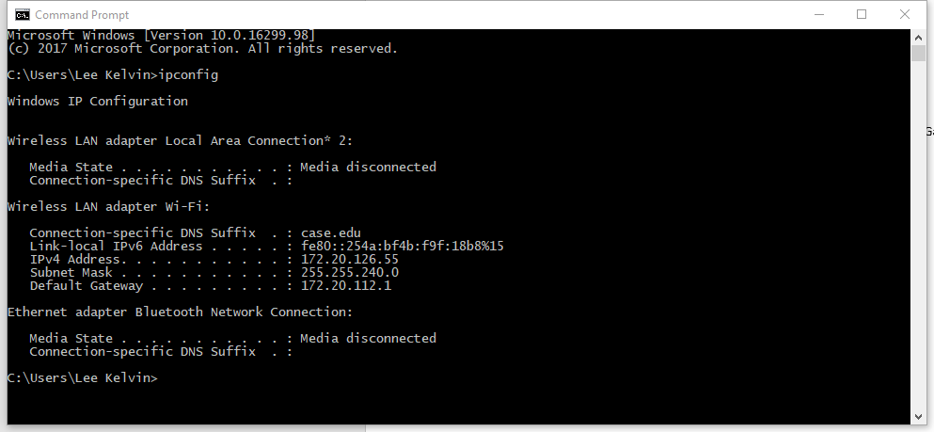

* **Folder “Cards” need to be in the same directory as Game, to prevent file I/O errors.**

### Launching:

* Runnable jar: Game.jar, Server.jar
* Deploy through source code: SE/src/main/Game.java - main, SE/src/server/Server.java - main
* Game: by default, no arguments. Run coverage tests, “-test”. (Server and Action Mocker will be deployed along the game)
* Server: by default, no arguments. Activate Action Mocker, “-test”. Deploy without javax.swing GUI, “-nogui”.

### Running:

* Login:

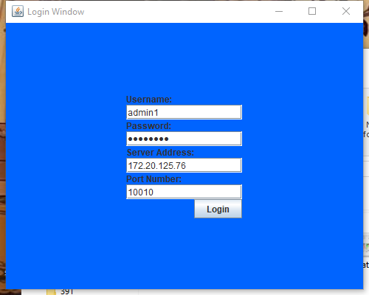

* Users: **<”admin0”, “password”>, <”admin1”, “password”>**. More users can be added by altering server.java source file’s main function.
* Server Address: **“localhost”, or the IP address of the device deploying the server.**
* Port: by default, **10010**. Cannot be changed unless altering the Server.java source file.
* Functioning buttons: Login, submit all information to the server.
* Possible notifications and popups: **“Incomplete fields”**, if either username or password is empty. **“Unknown host”**, if no internet connection or the server address is unavailable. **“Invalid port”**, if port number is not an integer.
* Main Window:

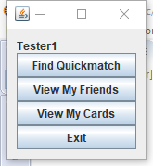

* Find Quickmatch:
* Enter the matching queue. If there are 2 or more people in the queue, server matches the first two players. A timer will show up to notify player, and leave queue by pressing “back” button.
* Possible notification and popups: **“Deck isn’t ready”**: number of cards in deck is not 15. **“Already in a match”**: Cannot start two matches simultaneously. **“Battle Request”**: After entering quick match and if someone is matched with you, you will see the follow window:

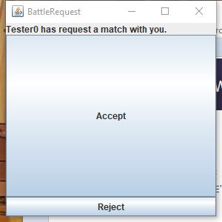

* Accept to start the game, or reject to cancel the combat.
* View My Friends:

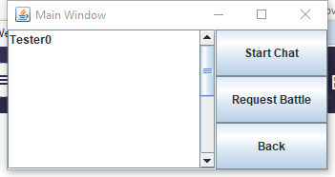

* Left is the list of friends (can be empty).
* Functioning buttons: **“Start Chat”**, opens the chat window with the selected friend (chat history kept), refocuses if the window is already open. **“Request Battle”**, send a battle request to the selected friend. **“Back”**, return to main window.
* Possible notification and popups: **“Already in a match”**, Cannot request another one when already in a match. **“Deck isn’t ready”**, cards in deck is not 15. **“No friend selected”**, no friend selected.
* View My Cards:

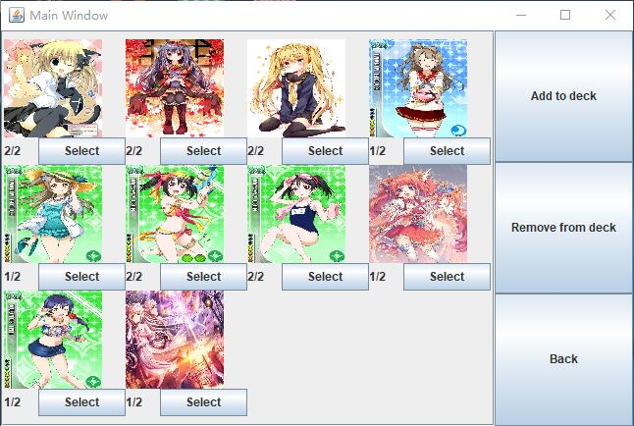

* Functioning buttons: **“Select”**, select this card. **“Add to deck”**, add the selected card to deck. “Remove from deck”, remove the selected card from deck. (Add and remove does not clear selection.) **“Back”**, return to the main window.
* **Image: Click on images will display the cards’ details and their on-board effects.**
* **Deck Limits: total exactly 15 cards. Individual cards cannot exceed 2.**
* Possible notifications and popups: **“Cannot add”**, either deck is full or individual cards is already 2/2. **“Cannot remove”**, no selected card present in deck. **“Deck isn’t completed”**, pressed back when deck is not 15 cards, matching features will be restricted.

### Card Battling

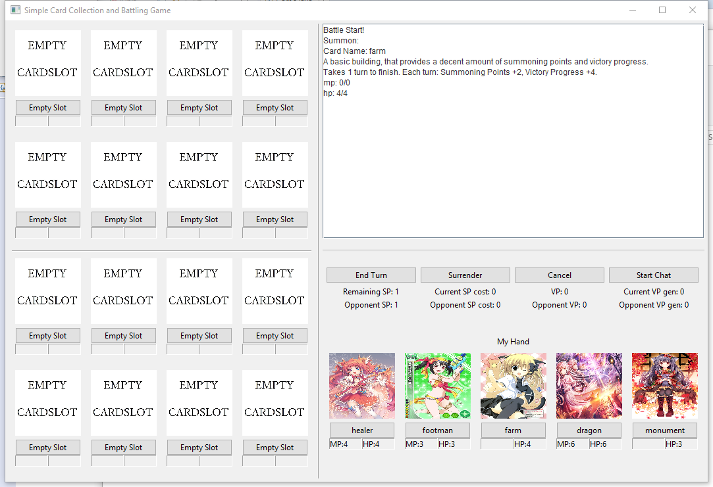

* The server determines first move, randomly.
* At the start of each turn: 1. Replenish hand to 5 cards. 2. All unfinished building waiting turn -1, finished buildings start taking effects. 3. SP recalculation: SP = 1 + all finished building’s SP – current SP cost.
* In-turn actions: **“Summon”**, summon a card from hand, by clicking on the name, and then an empty slot on the field; buildings will become unfinished buildings, and creatures takes effect immediately. **“Skill activation”**, some creatures and buildings have skills for activation, click on the card name, (some cards requires selecting an additional target for the skill), and the skill will take effect. “End turn”, ends turn. **“Cancel”**, cancels summon and skills that requires target (click card’s name – cancel - confirm); skill that does not require a target cannot be cancelled. **“Start Chat”**, open (or refocus) the chat window with the opponent.
* Cards’ removal upon death: when HP reaches 0, card is removed from the board, and the slot becomes empty again. If creature, its SP cost will be subtracted from the owner’s current SP cost. If building, its VP gen will be subtracted from owner’s current VP gen. If this card is not a **Token** (refer to the next line), an identical copy will be shuffled into player’s deck.
* **Token**: a card that is not summoned from player’s hand. Such as the “cost - free” dragon summoned by the finished summoning circle.
* **“Surrender”** can be pressed any time in match, even in opponent’s turn. Closing up the window also triggers surrender.
* Possible notifications and popups: **“Not enough mana”**, activating a skill that requires mana while the building or creature has insufficient mana. **“Not enough SP”**, trying to summon a monster that requires more SP than you have. **“Not a valid target”**, 1. Summon into opponent’s board, or a non-empty slot. 2. Attacking a backline monster when frontline is covered, or attacking an empty slot or ally. **“Your turn is finished”**, taking in-turn actions while in opponent’s turn. **“You won” or “You lost”**, one of the player has VP 100 or more, match terminating. **“Cancel confirmation”**, confirming the current action’s cancellation. **“Nothing to be cancelled”**, cancel inapplicable. **“Surrender confirmation”**, if confirmed, immediately ends the game
* At the end of each turn: 1. Creatures’ HP and MP regeneration, if they can. 2. VP recalculations: current VP gen = all finished building’s VP. VP = accumulated VP + current VP gen. 3. VP check: declares victory if VP >= 100.

### Authors

Lee Kelvin [lxk201@case.edu](mailto:lxk201@case.edu)

Qianxiang Ma [qxm28@case.edu](mailto:qxm28@case.edu)